How to Format a DataGridView

The following code demonstrates how to set the width of a column, the format in which the data in a column will be displayed and the cell alignment for a column.
There are many more properties that may be configured – use Google if you need to explore these.

class Utility
{
public static void formatGrid(DataGridView dg)
{
dg.Columns["ID"].Width = 30;
dg.Columns["ID"].DefaultCellStyle.Format = "000";
dg.Columns["ID"].DefaultCellStyle.Alignment = DataGridViewContentAlignment.MiddleCenter;

dg.Columns["Quantity"].Width = 70;
dg.Columns["Quantity"].DefaultCellStyle.Format = "000";
dg.Columns["Quantity"].DefaultCellStyle.Alignment = DataGridViewContentAlignment.MiddleCenter;

dg.Columns["Price"].Width = 60;
dg.Columns["Price"].DefaultCellStyle.Format = "N2";
dg.Columns["Price"].DefaultCellStyle.Alignment = DataGridViewContentAlignment.MiddleRight;
}

}

Another common request is to automatically resize the columns in a DataGridView so that the grid neatly fills all the available width with its cells. For example, in the ProductApp demo, when you list all the products in the Products table, the following GUI appears:

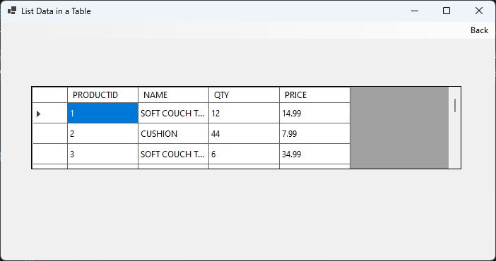

The DataGridView contains all the data required but notice that the NAME column is a little too narrow and there is “grey space” to the right that goes unfilled. This is really just a GUI design issue, but it is always good to make a GUI as presentable as possible for the end-user. To solve this problem, you can use code similar to the following here:

grd.Columns[0].AutoSizeMode = DataGridViewAutoSizeColumnMode.AllCells;
grd.Columns[1].AutoSizeMode = DataGridViewAutoSizeColumnMode.AllCells;
grd.Columns[2].AutoSizeMode = DataGridViewAutoSizeColumnMode.Fill;

where grd is a reference to the DataGridView object.

Note that in the code above it is assumed that there are just 3 columns in the DataGridView - the first two are set the same and will ensure that any text in the cell can be seen while the last column is set to “Fill” to ensure any remaining space is utilised. If it turns out that the last column is a bit too wide for the data it displays, it would be a good idea to go back to the Form Designer and make the DataGridView control a little narrower.

